**Chapter One**

**Introduction**

* 1. **Objective**

The main objective of the project is on an e-Healthcare , to reduce the manual work for managing the Doctors, Patients, an appointment booking system that provides patients or any user an easy way of booking a doctor’s appointment online, and tracking all the details about the Doctors according to user’s choice or demands.

Besides these it also provides the following functionalists:

* Shows hospitals names with details and location map
* Patients can predict their diseases by doing some answering of the questions about the diseases and find appropriate doctors
* Blog
* Google translation
  1. **Motivation**

This project is to increase people’s awareness about regular checkups and minimize confusions and all indecision to choose specific specialized doctors and making easy doctor patient relationship and proper treatment process one can possibly find.

* 1. **Tools**

**1.3.1 Hardware:**

* PROCESSOR : Intel Core i5-7200U up to 3.1GHz
* RAM : 1 TB
* HARD DISK : 4 GB
  + 1. **Software**
* XAMPP server environment
* Dreamweaver

**1.3.3 Languages:**

***Front-end:***

* HTML5
* CSS3
* Bootstrap Framework (for responsiveness)
* JavaScript/ JQuery
* Goggle API

***Back-end:***

* PHP framework
* ajax
* MySQL Database

**1.4 Methodology**

Methodology is a collection of procedure, techniques, tools and documentation aids that help the system development in their effort to implement a new information system. The propose approach is wanted to meet the goal of doing all manual works.

**Chapter Two**

**Problem Statement**

**2.1 Problem Statement**

The main goal of this project is to create a fully functioning online medical services solution ready to be deployed on the doctor-patient community:

* Get general understandings of an e-Healthcare (make an appointment) management system.
* Get a general understanding of a PHP framework and sql (mysql)
* Discussed the result of the proposed work
* Admin should have some medical knowledge

**Chapter Three**

**Literature Review**

**3.1 Project Life Cycle**

The project life cycle includes various development phases that occur in the life of project  
starting right from the inception of the project to its final development at the member’s end. The three development phases in a project life cycle are:

* Project initiation
* Project execution
* Project deployment

**3.1.1 Project initiation:**

The project initiation phase is first phase of life cycle. This phase involves creating a complete  
plan for the project, specifying various activities that will be performed and assigning  
responsibilities to team members on the basis of their skill set.

**3.1.2 Project execution:**

After the project plan is made and the responsibilities assigned, the actual development of the  
project starts. The phase in which the actual development of the project takes place is known as the project execution phase. This is the most crucial phase of any project and is subdivided into the following phases:

1. System analysis

* Initial Study
* Information Gathering
* Feasibility Study

2. System Design

* Design standard
* High level design & design tools
* Database design
* Logical design
* Construction

3. System Implementation

* Combination and testing
* Post execution

**3.1.3 Project development:**

After the undertaking execution stage, the last period of a venture life cycle is the task  
advancement stage. In this stage the conveyed at the member side. This stage additionally  
includes giving client backing to the member for some predefined time frame.  
At the point when undertaking is manufactured it might potentially remain blunder less of  
additional, in light of the fact that few sort of alteration can happen a few times. So for the first  
run through when we run the database site we discovered couple of issues in instruments  
segments. We altered this issue including some minor issues quickly, and subsequently the  
application runs legitimately.

**Chapter Four**  
**Project Modules & System Analysis**

**4.1 Project Module**

The entire project mainly consists of 3 modules, which are

* Admin module
* User module (patient)
* Doctor module

**4.1.1 Admin module:**

* To see all the doctors lists with status
* Can add doctors for membership of this site and can remove doctor's an account
* To see all the users/patients list with status
* Can remove accounts of users
* To see all the doctors registration request and can approve or delete their account
* Can send confirmation message to the doctors about an approval or deleting their request
* To see all the appointments
* To see all the comments from the visitors or users about the site and blog
* Can write blogs

**4.1.2 Doctor module:**

* Manage own profile
* Manage own appointment schedule
* See all the appointments request from the patients with their(patients) status and can approve or cancel booking
* Can see the messages from all the users and send back text to them(patients)
* Can see the notify messages from the users who are cancel appointments
* Can comment about the site and blog

**4.1.3 User/patient module**

* Manage own profile
* Can predict their diseases
* Can see all the doctors list with their(doctors) status
* Can search doctors by their names
* Make an appointment according to their own choice or demands
* Can see their own appointments and manage their appointments(cancel booking)
* Can see the notify messages from the doctors who are approved or cancel his/her appointments
* Can send a messages for an emergency to the doctors and can reply doctors text
* Can comment about the site and blog

**4.2 System Analysis**

* Existing System
* Proposed System
* Feasibility Study

**4.2.1 Existing System**

Many hospitals or clinics currently use a manual system for the management and maintenances of critical information. This system requires numerous paper forms, calling for ensuring availability of doctors’ and have confusions and all indecision to choose specific specialized doctors.

**4.2.2 Proposed System**

This project system is to control the information of doctors, patients, schedules, patient invoices, and locations of hospitals.

**4.2.3 Feasibility Study**

**4.2.3.1 Operational Feasibility**

* **Time savings**

Our Health-Care system can save time. For example, patients can schedule their own appointment with their care provider online. In addition, they do not even need to leave their home if they can arrange an online consultation (for example).

* **Insight into own health**

A personal digital health care environment gives people more insight into their health. If they wish, they can share all or part of their data with a health care provider or informal care, so that they do not have to repeatedly relate their entire medical history. This allows the health care provider to work more effectively, determine the right treatment more quickly, and avoid mistakes. Patients gain more control over their own health thanks to a greater understanding of their health situation.

* **Lower administrative burden**
* Doctors have less paperwork and can share information securely and easily with colleagues.
* Not all health care providers currently offer health-care. However, health care providers and patients are becoming more aware of the benefits. Many doctors now offer patients the opportunity to schedule appointments online. Around 46% of patients would like to have online access to their medical records (source: E health Monitor 2015), but this can only be done if there are good safeguards for privacy.
* **Others**
* Users can get appointment from here. In order to get an appointment, at first users need to login at this site. If users are not registered, they need to do registration first. Users can still get locations about other nearest hospitals from this website.
* Users can translate this site in any languages, read articles about health-care without registration.

**4.2.3.2 Technical feasibility**

* Users can easily use this site
* They do not need to any sort of ID (Gmail or social).
* They do not require registration to know about doctors’ information. Also easily get access to the locations of other hospitals.
* Site will be accessed easily from other browsers.
* For an appointment, first users need to login at this site. If someone is not registered, must need to register first.

**4.2.3.3 Economic Feasibility**

Our health-care system will interact with different websites like hospital operators. (What actually you mean here?)

**Chapter Five**

**System Design**

**5.1 Introduction**

Design is the step in the development phase for any techniques and principles for the purpose of defining a device, a process or system in sufficient detail to permit its physical realization.

Once the software requirements have been analyzed and specified the software design involves three technical activities - design, coding, implementation and testing that are required to build and verify the software.

The design activities are of main importance in this phase, because in this activity, decisions ultimately affecting the success of the software implementation and its ease of maintenance are made. These decisions have the final bearing upon reliability and maintainability of the system. Design is the only way to accurately translate the customer’s requirements into finished software or a system.

Design is the place where quality is fostered in development. Software design is a process through which requirements are translated into a representation of software. Software design is conducted in two steps. Preliminary design is concerned with the transformation of requirements into data.

**5.2 Diagram**

This chapter includes DFD (Data Flow Diagram), ERD (Entity Relationship) and Schema Diagram.

**5.3 Data Flow Diagram (DFD)**

The data flow diagram is one of the improvement tools used by the system analysts. DE Marco (1978) and Gane Sarson (1979) popularized the use of the data flow diagram as modeling tool through their structured system analysis methodologies.

Data flow diagram illustrates how the data is processed by a system in terms of inputs and outputs. A data flow diagram should be the first tool used by system analyst to model system components. There components are the system processes, the data used by these processes and external entities that interact with the system and the information flow in the system.

Data flow diagram will act as a graphical representation of the system in terms of interaction between the system, external entities, and process and how data stored in certain location.

There are four kinds of system components:

* External entities:
* They are the repositories in the system, also referred to as files.
* Data stores:
* They are the repositories in the system, also referred to as files.
* Process
* It transforms the incoming data flow into outgoing data flow.
* Data flow
* They are pipelines through which packets of information flow. Label the arrows with the name of the data that moves through it.

**5.3.1 Context diagram of e-health-care using System:**

User

View & make appointment

Hospital locations, doctors details, Blog BlogBlogBlog

View patient appointment request list & hospital location, Blog

Doctor

0

Site using

system

Update appointment schedule, Add patient appointment request

Add doctor, reject/remove account/approved doctor, Update hospital loc., Update blog

View doctor list, user list, list of all appointment

Admin

**Fig: 5.3.1 e-health-care System Data Flow Diagram**

**5.3.2 e-health-care using system between user &admin DFD:**

Searching by doctor name

1.0

Receive transform user searching

User

Show doctor name

Inventory data

Doctors info.

2.0

Update doctors information

3.0

Update

Inventory data

Formatted inventory data

Formatted doctors info. data

Update doctors info data

Add content data

4.0

Add or update content/file

D2 Inventory file

D1 doctors info. file

Add or update content

Admin

**Fig: 5.3.2 System between user & admin Data Flow Diagram**

**5.3.3 2 e-health-care using system between user & doctor DFD:**

Request for appointment

Make/ accept user appointment

1.1

Receive & transform user demand

User

Show doctors available time

Doctor

View patient request

3.1

Fill up the list

2.1

Show available appointment time list

**D1** Requirement for making appointment

D2 store in database

4.1

Verification

**D3 Approved**

**Fig 5.3.3 System between user & doctor Data Flow Diagram**

**5.3.4e-health-care system between doctor & admin DFD:**

Fill up with valid info.

**Admin**

**Doctor**

Update content

**1.2**

**Show & receive all information**

Show register from

Show request from doctors

**D1 Require Data**

**2.2**

**Verification**

**D2 Approved/Reject**

**Fig 5.3.4 System between doctor & admin Data Flow Diagram**

**5.4 Entity Relationship Model**

Entity Relation model is a graphical representation of the data for an organization. It uses mainly three construct i.e. data entities, relationship and their associated attributes.

**Entities:**

An entity is a fundamental thing of an organization about which data may be maintained. An entity has its own identity which distinguishes it from other entity.

**Relationships:**

A relationship is a reason for associating two entity types and it is called binary relationships because they involved two entity types. Some form of data model allows more than two entity types to be associated. Relationships are represented by diamond notation in the E-R diagram.

**Attributes:**

Attributes are the descriptive properties possessed by each member of an entity set.

**Overall ER diagram**

**Admin**

**admin_Id**

admin_pswd

**Doctor**

**ID**

First_name

Last_name

Email_address

Contact_number

Specialist

Qualification

Password

Permission

Permission_date

Approved

View

View

**Schedule**

**Schedule_id**

Doctor’s ID(F.K)

time

Update/

Cancel

**User/Patient**

**ID**

First_name

Last_name

Email_address

Password

Contact_num

DOB

Age

Gender

Registration_date

View/

Book

**User registration &login E-R Diagram:**

**User**

**ID**

First_name

Last_name

Email_address

Password

Contact_number

DOB

Age

Gender

Registration_date

**Registration from**

**ID**

First_name

Last_name

Email_address

Password

Contact_number

DOB

Age

Gender

Being a member

**Fig 5.4.1: Entity Relationship Diagram**

**Doctor registration & login E-R Diagram:**

**Admin**

**Id**

password

**Registration From**

**ID**

First_name

Last_name

Email_address

Contact_number

Specialist

Qualification

Password

Approve/

Delete

**Doctor**

**ID**

First_name

Last_name

Email_address

Contact_number

Specialist

Qualification

Password

Permission

Permission _date

After approved

**Fig 5.4.2: Entity Relationship Diagram**

**Appointment process of ER diagram**

**Admin**

**Id**

password

Accept/

cancel

view

**User**

**ID**

First_name

Last_name

Email_address

Password

Contact_num

DOB

Age

Gender

Registration_date

**Appointment**

**Appointment_id**

Booking_date

Booking_time

Permission

Permission_date

Patient_id(F.K)

Doctor_id(F.K)

**Doctor**

**ID**

First_name

Last_name

Email_address

Contact_number

Specialist

Qualification

Password

Permission

Permission_date

view

make

Add time

**Schedule**

**Schedule_id**

Doctor_id(F.K)

time

add

view

**Fig 5.4.3: Appointment process of ER diagram**

**Blog-comment section process of ER diagram**

**User**

**ID**

First_name

Last_name

Email_address

Password

Contact_num

DOB

Age

Gender

Registration_date

**Doctor**

**ID**

First_name

Last_name

Email_address

Contact_number

Specialist

Qualification

Password

Permission

Permission_date

**Admin**

**Id**

password

Update/delete

**Blog_comment**

Comment_id

Parent_comment_id

Comment_sender_email

Comment

Date

View/ comment

View/ comment

**Fig 5.4.4: Message and Blog comment section process of ER diagram**

**Messaging process of ER diagram**

**Doctor_message**

**Text_id**

Doctor_id**(F.K)**

Patient_id**(F.K)**

Text

Sending_Date

Send

view

**User**

**ID**

First_name

Last_name

Email_address

Password

Contact_num

DOB

Age

Gender

Registration_date

**Doctor**

**ID**

First_name

Last_name

Email_address

Contact_number

Specialist

Qualification

Password

Permission

Permission_date

**User_message**

**Text_id**

Doctor_id**(F.K)**

Patient_id**(F.K)**

Text

Sending_Date

Send

view

**Fig 5.4.5: messaging process of ERD**

**5.5 Schema Diagram**

This is an overview of all the flowchart symbols that you will use when drawing flowcharts and process flow. All these objects are available in create and we can try out a demo or take a look at our sample flowchart for more context.

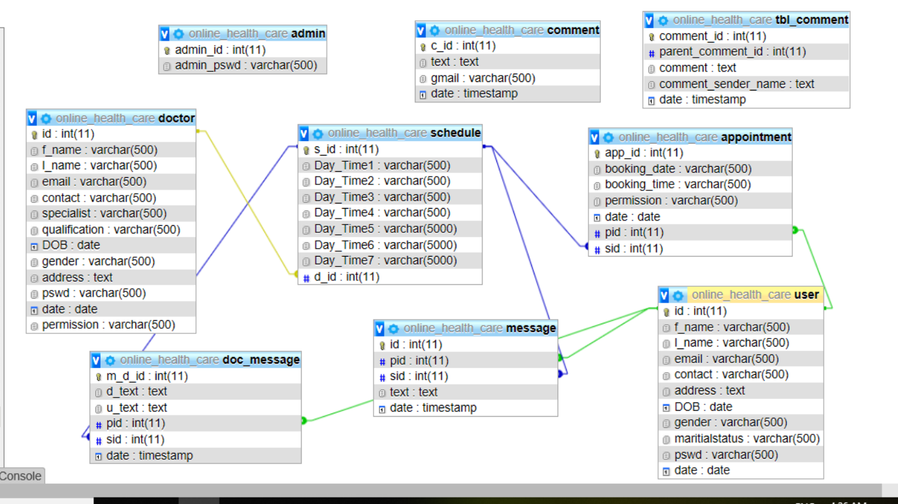

**Fig 5.5: Schema Diagram**

**5.6 Summary**

When a project is approved then very initial step is planning. Next is to decide project specification and design that where the project scope is to apply. After complete this step need to collect the required equipment that is necessary for approved project. This required equipment is called requirements. Our e-HealthCare management solution project is created by using, MySQL, Nice admin template and HTML5 responsive template.

**Chapter Six**

**Project Layout & Snapshots’**

**6.1 Introduction**

Here we are discussing about the whole projects with their some snapshots.

In figure 6.1 there are five navigation bars with searching option.

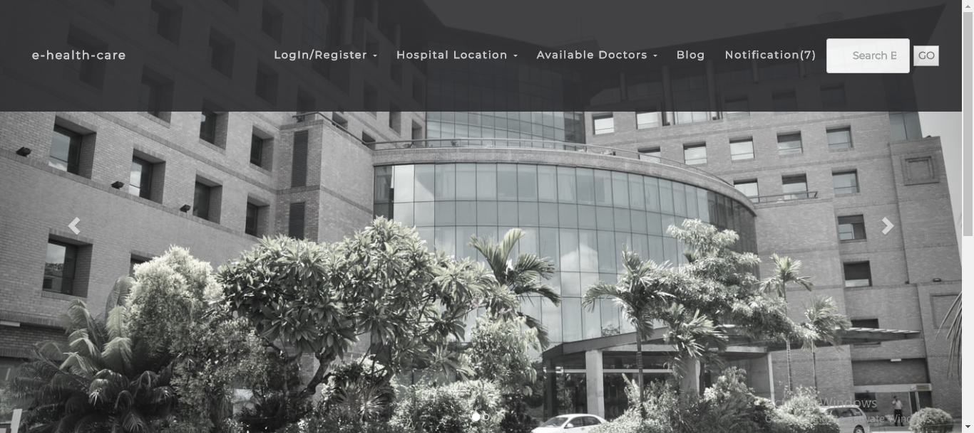

**Fig 6.1: Front page**

When visitors (any person) visit these sites; they can see/do these following functionalists are

1. See Hospitals list with their respective location (Hospital Location) [Figure 2,3]
2. See the Doctors List with their appropriate status. (Available Doctors)
3. See an article about this site, medical term and viewers can comment. [Figure 4,5]



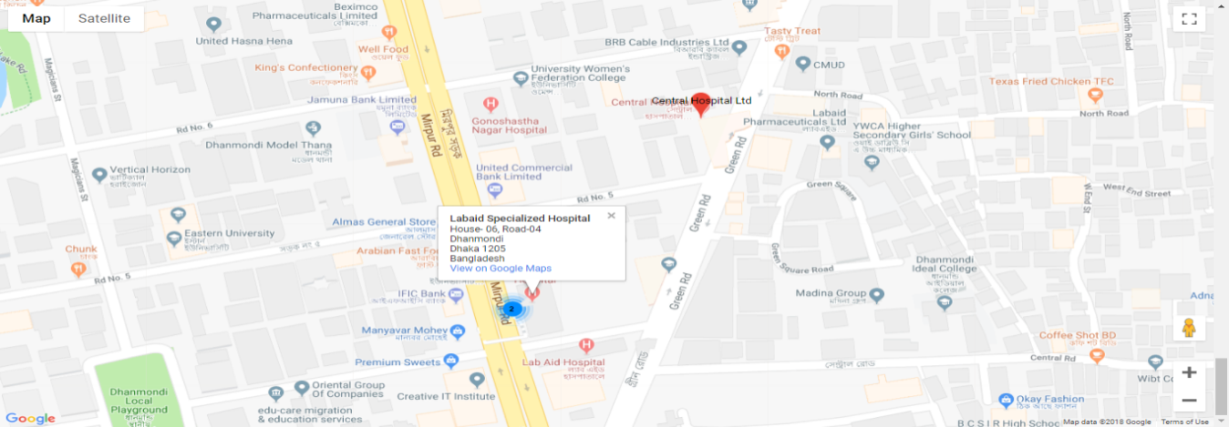 **Figure 6.2: Hospitals names list**

**Figure 6.3: Show location**



**Figure 6.4: An Article**

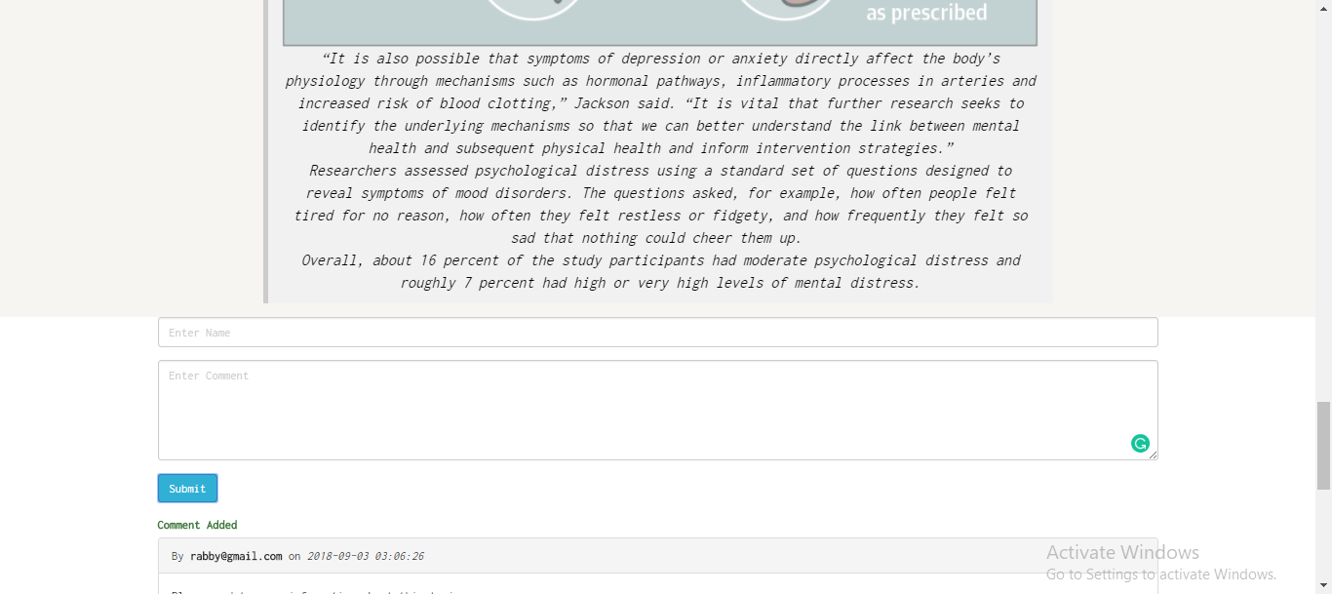

**Figure 6.5: Comment section**

**6.1.1 User Section:**

In this section the main objective is to make an appointment. For making an appointment, they have to fill up the registration form to open an account. And then they can get a proper guidance and specific treatment from this site with their own account.

Some snapshots are given below:

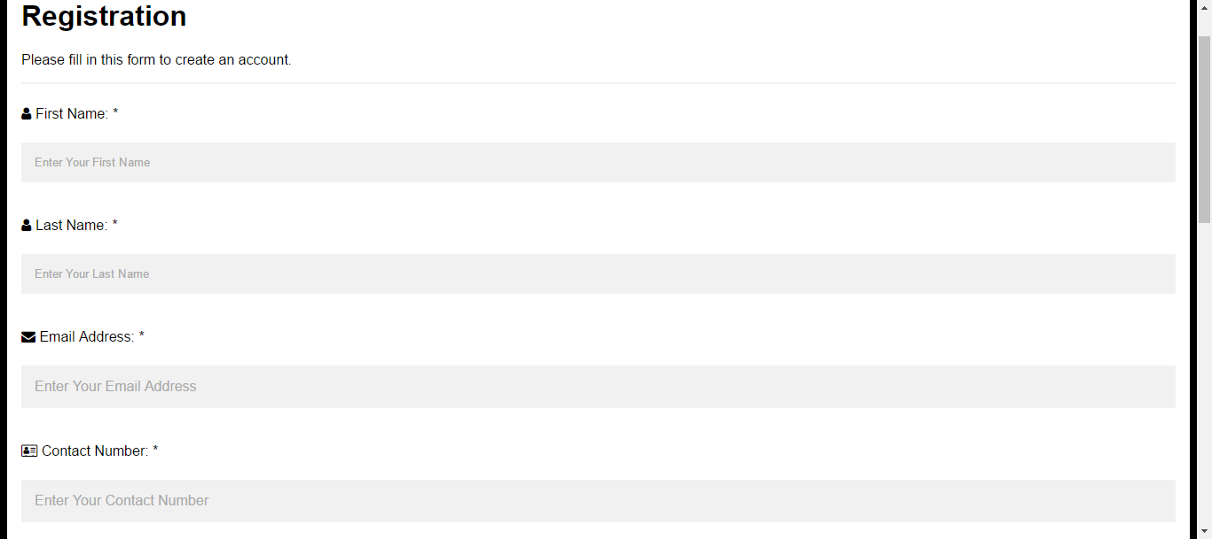

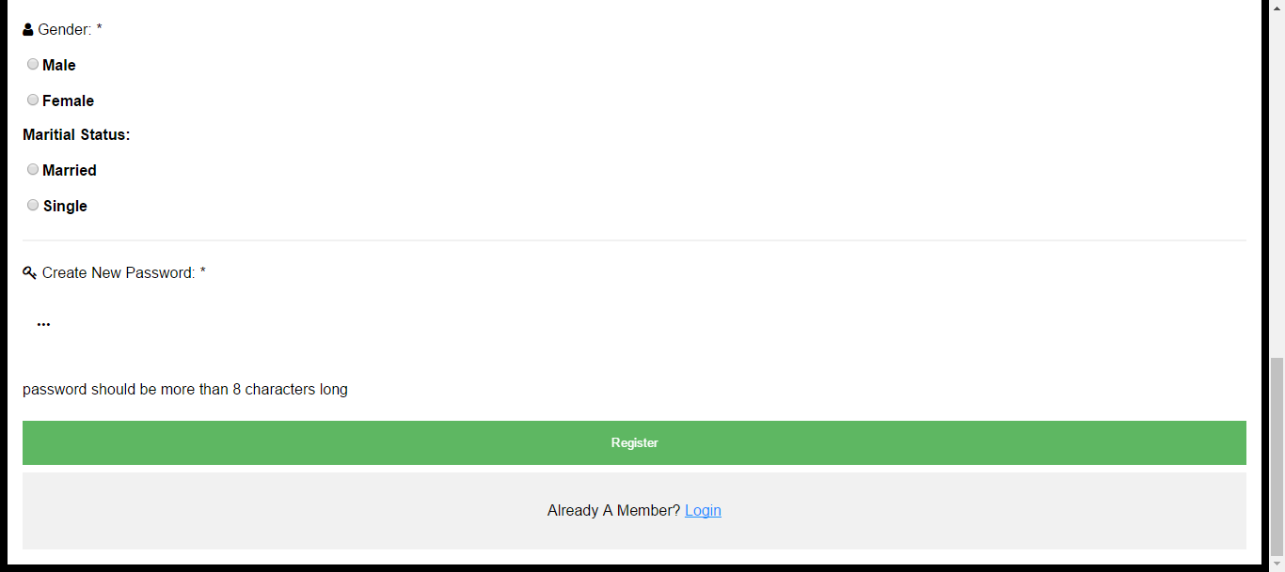

**Figure 6.1.1.1: User’s Registration Form**

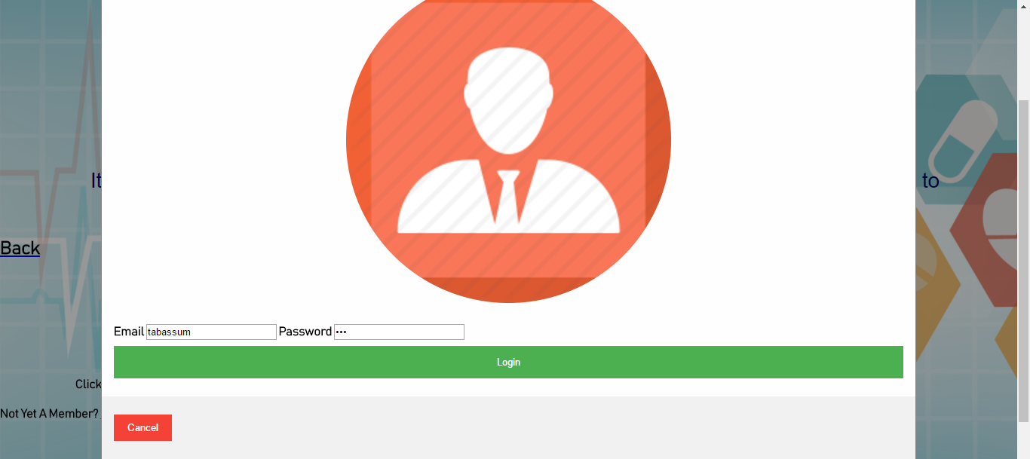

**Figure 6.1.1.2: User’s Login**

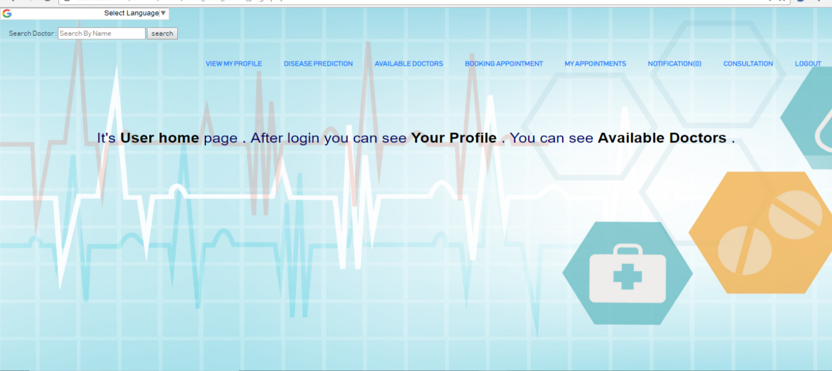

**Figure 6.1.1.3: User’s Home Page**

In figure 6.1.1.3; this is the user’s home page. And there is eight sections with searching bar. Booking appointments some snapshots are

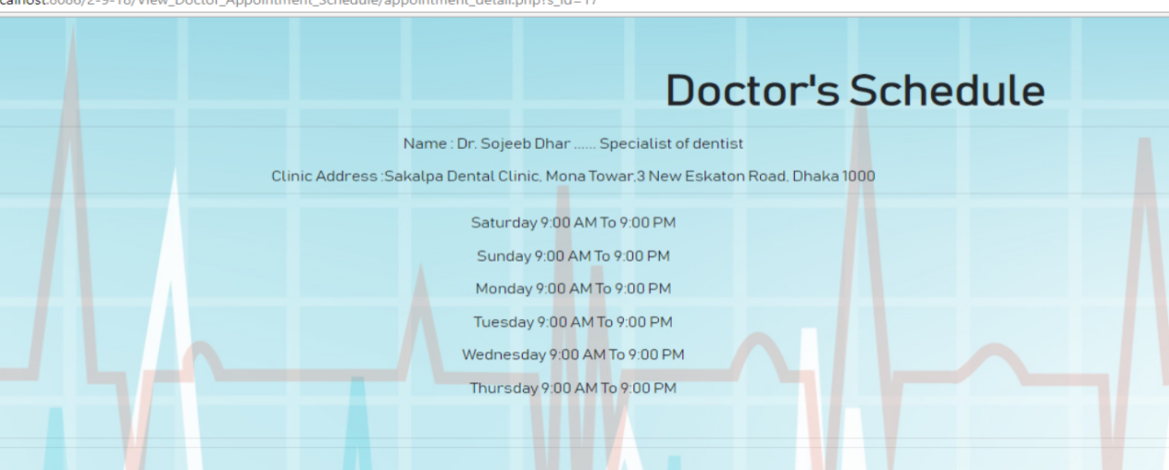

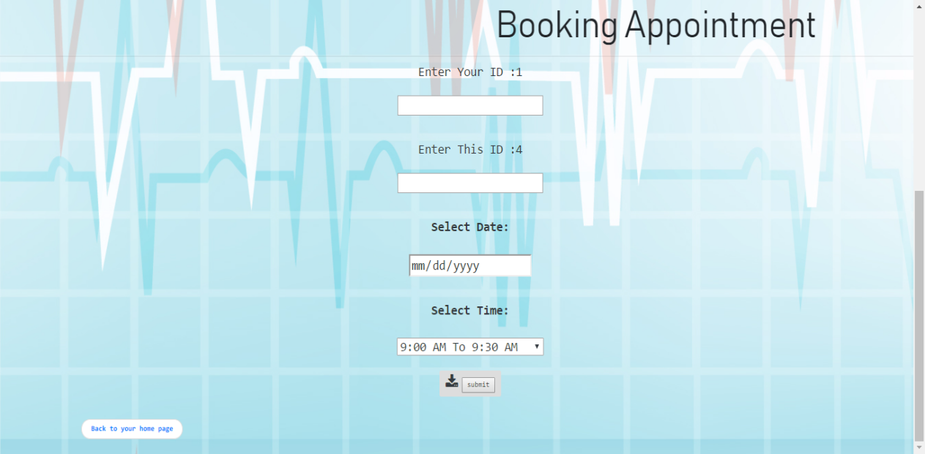

**Figure 6.1.1.4: Make an Appointment**

Besides this, user can do the following functionalities:

1. Manage his/her own profile like update their profile information (view my profile)
2. Predict his/hers diseases for finding a trustworthy doctor to treatment (Disease Prediction) [Figure 6.1.1.5]

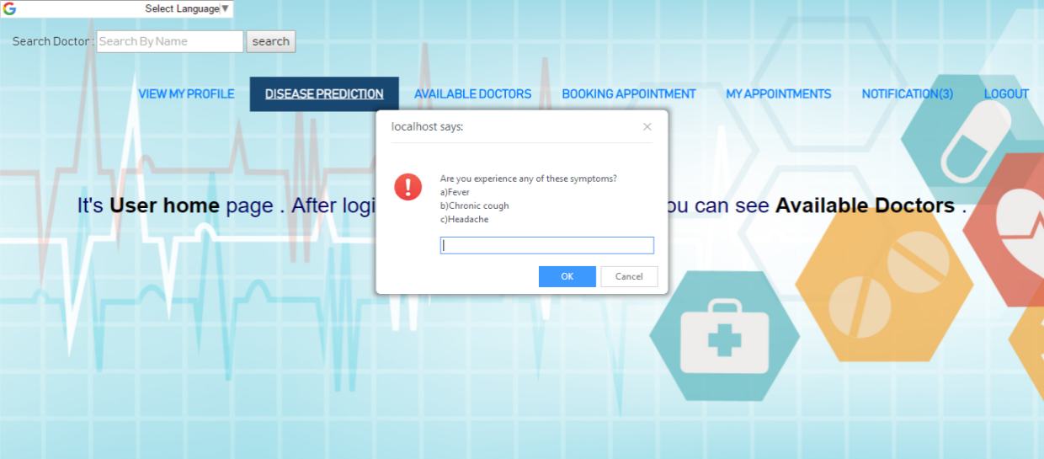

**Figure 6.1.1.5: Disease Prediction**

1. See the list of all the doctors with their status (Available Doctors)
2. See his/hers own appointments (My appointments)
3. Get a message from the doctors for appointment approval/rejection (Notification)
4. Consultant with doctors about their disease(Consultation) [Figure 6.1.6]

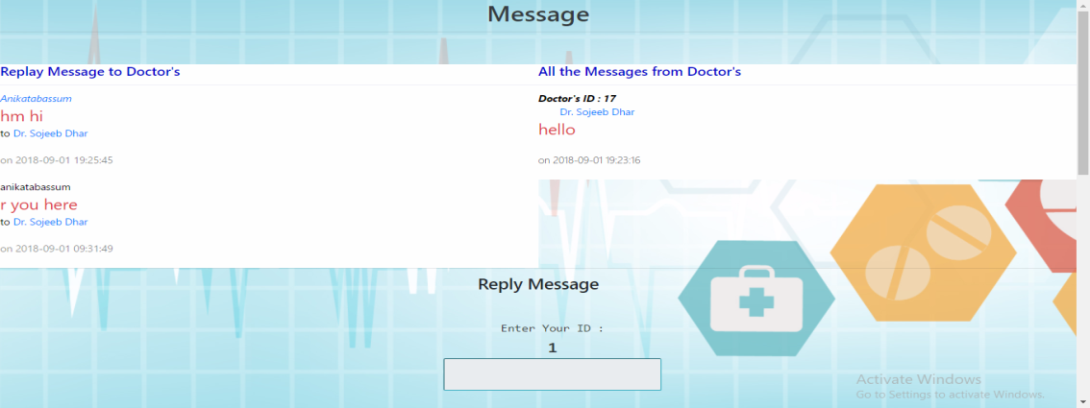

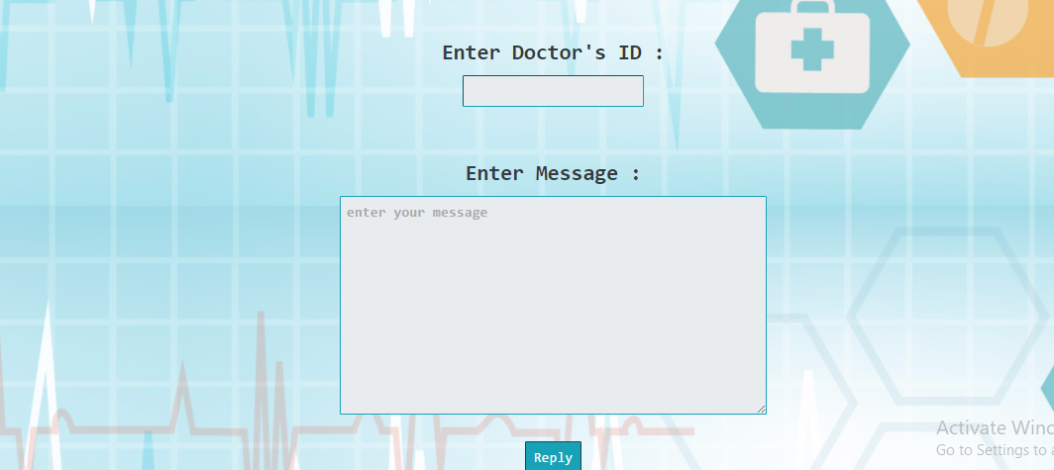

**Figure 6.1.1.6: Consultation**

**6.1.2 Doctor Section**

In this section doctors have to fill ups the registration form from this site with their valid medical certificate uploading and waiting for the admins approvals (snapshot-same as users registration form some attributes is different). Doctors can login their own account with approval from the admin. And this section doctor’s main objective is to manage patients’ appointments (approved or cancel booking).

Some snapshots are

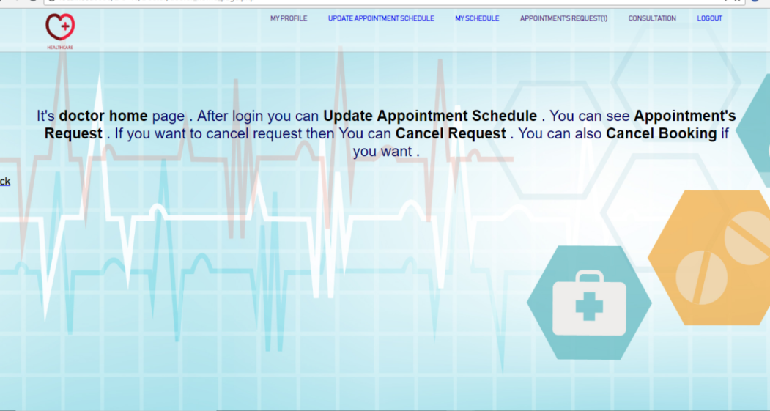

**Figure 6.1.2.1: Doctors Home Page**

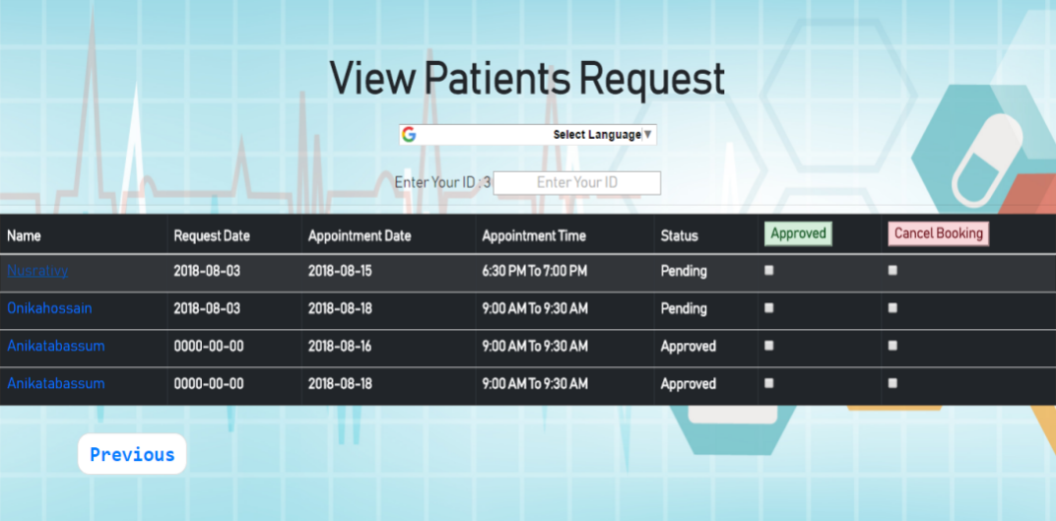

**Figure 6.1.2.2: Manage Patients Appointments**

Beside this; they can do these functionalities

1. Manage his/hers own profile like updating their status(My Profile)
2. Manage his/hers schedule (Updating schedule, My Schedule)
3. Get a message from the patients if they (patients) reject their appointments. (notification)
4. Can consult with patients (Consultation) figure 6.1.2. 3

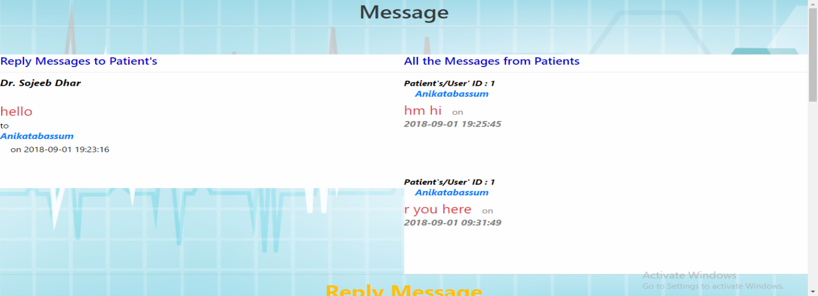



**Figure 6.1.2.3: Consulting with patients**

**6.1.3 Admin Section**

Here is the main objective is admin can control all the activities.

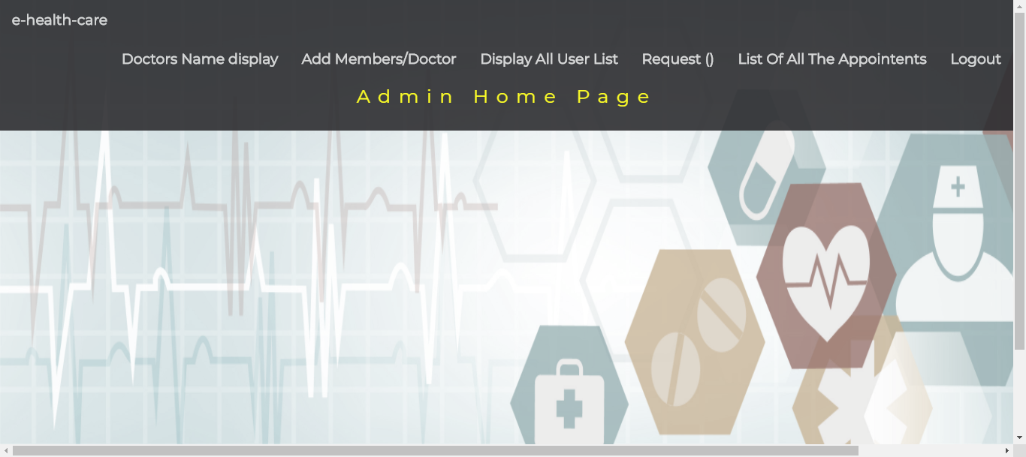

**Figure 6.1.3.1: Admins Control panel/Home page**

So after login he/she can do these functionalities:

1. See the doctors list and can remove them from his site (Doctors Name Display)

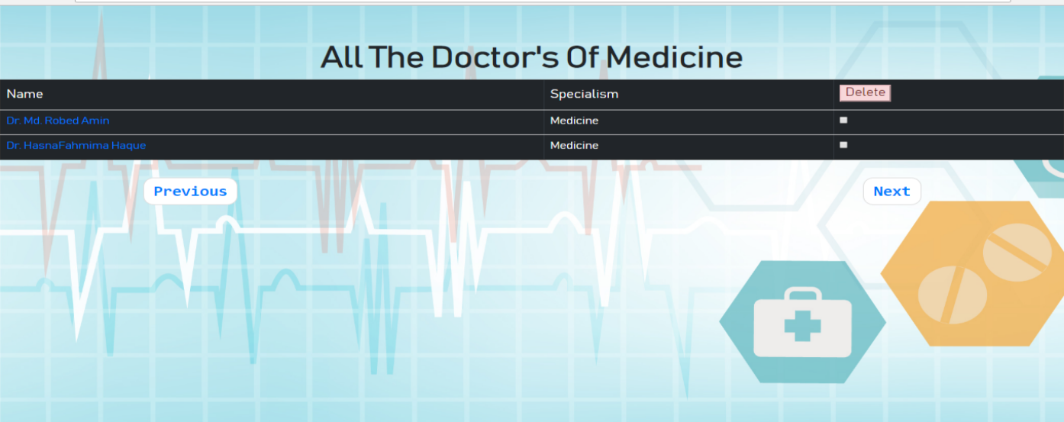

**Figure 6.1.3.2: Manage all the doctors (approve/reject)**

1. Can Add Doctors (Add doctors)

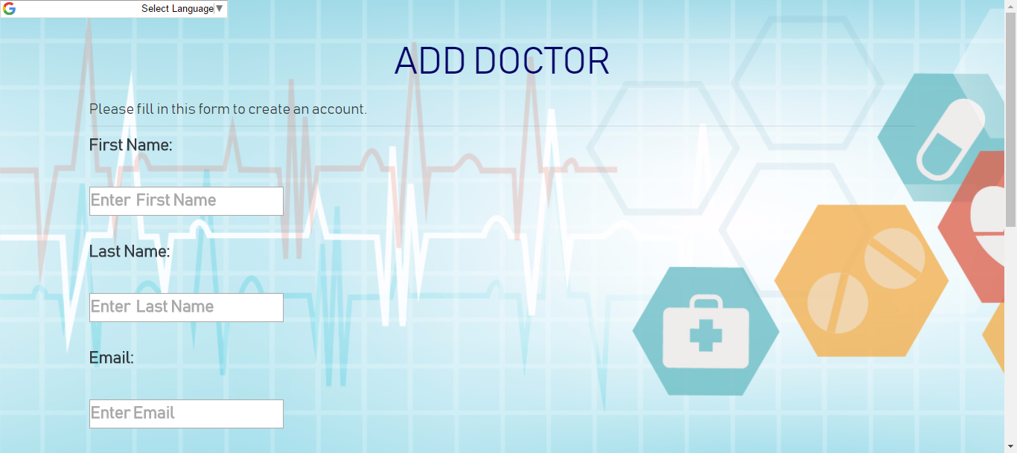

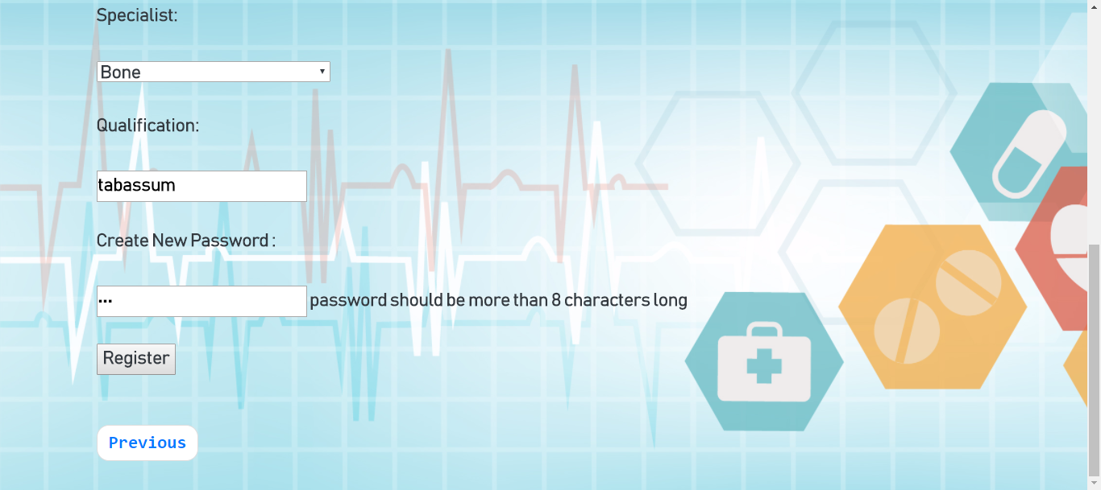

**Figure 6.1.3.3: Add doctors**

1. See the entire user’s list and can remove their account

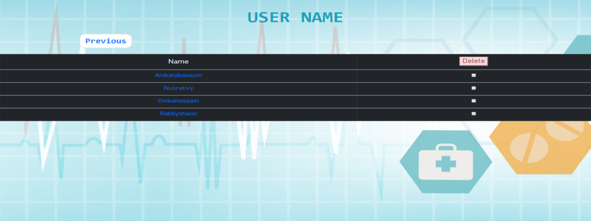

**Figure 6.1.3.4: Manages all the users (remove account)**

1. Manage all the doctors registration request like approve/rejection (Request)

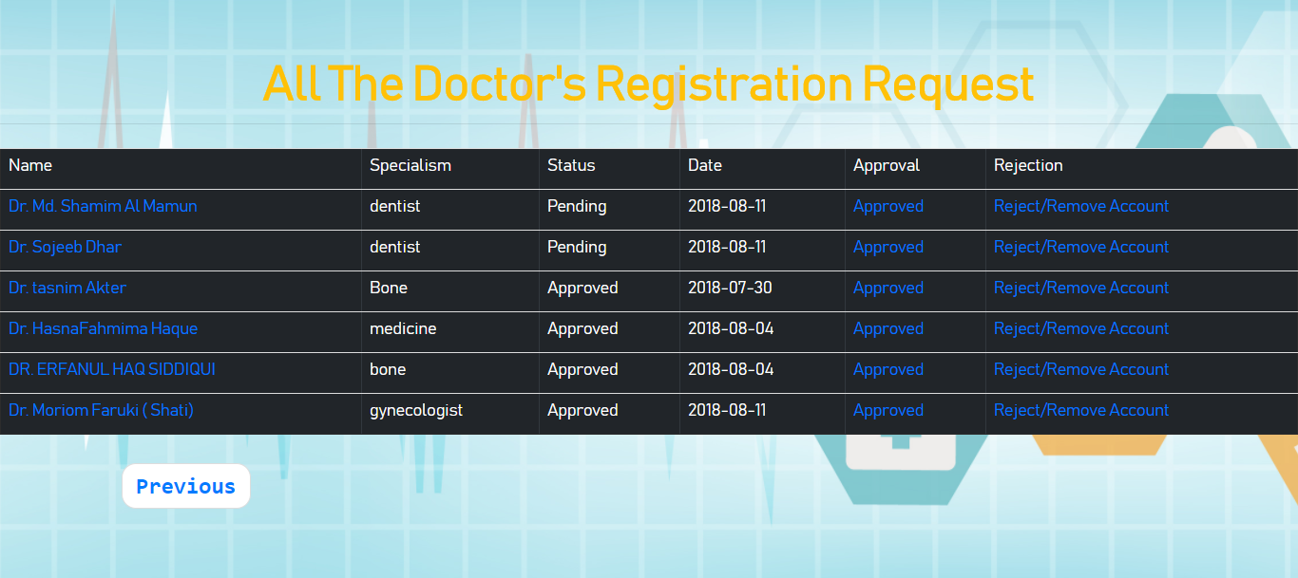

**Figure 6.1.3.5 approval request and manage (approve/rejection)**

1. Can see all the appointments (List of all the Appointments’)

This is all about the project.

**Chapter Seven  
Testing**

**7.1 Software Testing**

Software testing is an investigation conducted to provide stakeholders with information about the quality of the product or service under test [1]. Software testing can also provide a objective, independent view of the software to allow the business to appreciate and understand the risks of software implementation. Test techniques include, but are not limited to, the process of executing a program or application with the intent of finding software bugs (error or other effects).

Software testing can be stated as the process of validating and verifying that a computer  
program/application/product:

1. Meets the requirements that guided its design and development
2. Works as expected
3. Can be implemented with the same characteristics
4. And satisfies the needs of stakeholders

Software testing, depending on the testing method employed, can be implemented at any time in the development process. Traditionally most of the test effort occurs attar the requirements have been defined and the coding process has been completed, but in the Agile approaches most of the test effort is on-going. As such, the methodology of the test is governed by the chosen software development methodology.

**7.2 Characteristics of Good Test**

An excellent test case satisfies the following criteria:

* It has a reasonable probability of catching an error  
   you test to find errors. When searching for ideas for test cases, try working  
   backwards from an idea of how the program might fail. If the program could fail  
   in this way, how could you catch it?
* It is not redundant  
   if two tests look for same error, why run both?
* It’s the best of its breed  
   in a group of similar tests, one can be more effective than the others; you want  
   the best of the breed, the one most likely to find the error.
* It is neither too simple nor too complex

You can save testing time by combining two or more tests into one test case.  
 But don’t create a monster that’s too complicated to execute or understand or  
 that takes too much time to create. It’s often more efficient to run simpler  
 tests. Be cautious when combining invalid inputs.

**7.3 Black box Testing**

The technique of testing without having any knowledge of the interior working of the application is Black Box testing. The tester is oblivious to the system architecture and does not have access to the source code. Typically, when performing a black box test, a tester will interact with the system’s user interface by providing inputs and examining outputs without knowing how and where the inputs are works upon.

**7.4 White Box Testing**

White box testing is the detailed investigation of internal logic and structure of the code. White box testing is also called glass testing or open box testing. In order to perform white box testing on an application, the tester needs to possess knowledge of the internal working of the code. The tester needs to have a look inside the source code and find out which unit/chunk of the code is behaving inappropriately.

**7.5 Grey Box Testing**

Grey box testing is a technique to test the application with limited knowledge of the internal working of an application. In software testing, the term the more you know the batter carries a lot of weight when testing an application. Mastering the domain of a system always gives the tester an edge over someone with limited domain knowledge. Unlike black box testing, where the tester only tests the application’s user interface, in grey box testing, the tester has access to design documents and the database. Having this knowledge, the tester is able to better prepare test data and test scenarios when making the test plan.

**7.6 Unit Testing**

In computer programming, unit testing is a method by which individual units of source code, sets of one or more computer program modules together with associated control data, usage procedures, and Operating procedures, are tested to determine if they are fit for use. Intuitively, one can view a unit as the smallest testable part of an application. In procedural programming a unit could be an entire module but is more commonly an individual function or procedure. In object-oriented programming a unit is often an entire interface, such as a class, but could be an individual method. Unit tests are created by programmers or occasionally by white box testers during the development process .Ideally, each test case is independent from the others: substitutes like method stubs, mock objects, fakes and test harnesses can be used to assist testing a module in isolation. Unit tests are typically written and run by software developers to ensure that code meets its design and behaves as intended.

**7.7 Integration Testing**

Integration testing is a logical extension of unit testing. In its simplest form, two units that have already been tested are combined into a component and the interface between them is tested. A component, in this sense, refers to an integrated aggregate of more than one unit. In a realistic scenario, many units are combined into components, which are in turn aggregated into even larger parts of the program. The idea is to test combinations of pieces and eventually expand the process to test your modules with those of other groups. Eventually all the modules making up a process are tested together . Beyond that, if the program is composed of more than one process, they should be tested in pairs rather than all at once.

Integration Testing identifies problems that occur when units are combined. By using a test plan that requires you to test each unit and ensure you the viability of each before combining units, you know that any errors discovered when combining units are likely related to the interface between units. This meth method reduces the number of possibilities to a far simpler level of analysis.

**7.8 The Nature of Software Defects**Logic errors and incorrect assumptions are inversely proportional to the probability that a  
program path will be executed. General processing tends to be well understood while special case processing tends to be prone to errors. We often believe that a logical path is not likely to be executed when it may be executed on a regular basis. Our unconscious assumptions about control flow and data lead to design errors that can only be detected by path testing. Typographical errors are random.

**7.8.1 Basis Path Testing**

This method enables the designer to derive a logical complexity measure of a procedural design and use it as a guide for defining a basis set of execution paths. Test cases that exercise the basis set are guaranteed to execute every statement in the program at least once during testing.

**7.8.1.1 Flow Graphs**

Flow graphs can be used to represent control flow in a program and can help in the derivation of the basis set. Each flow graph node represents one or more procedural statements. The edges between nodes represent flow of control. An edge must terminate at a node, even if the node does not represent any useful procedural statements.

A region in a flow graph is an area bounded by edges and nodes. Each node that contains a  
condition is called a predicate node. Cyclamate complexity is a metric that provides a  
quantitative measure of the logical complexity of a program. It defines the number of  
independent paths in the basis set and thus provides an upper bound for the number of tests that must be performed.

**7.8.2 The Basis Set**

An independent path is any path through a program that introduces at least one new set of  
processing statements (must move along at least one new edge in the path). The basis set is not unique. Any number of different basis sets can be derived for a given procedural design

**7.8.2.1 Automating Basis Set Derivation**

The derivation of the flow graph and the set of basis paths are amenable to automation. A  
software tool to do this can be developed using a data structure called a graph matrix. A graph  
matrix is a square matrix whose size is equivalent to the number of nodes in the flow graph.  
Each row and column corresponds to a particular node and the matrix corresponds to the  
connections (edges) between nodes. By adding a link weight to each matrix entry, more  
information about the control flow can be captured. In its simplest form, the link weight is 1 if an edge exists and 0 if it does not. But other types of link weights can be represented:

* The probability that an edge will be executed,
* The processing time expended during link traversal,
* The memory required during link traversal, or
* The resources required during link traversal

Graph theory algorithms can be applied to these graph matrices to help in the analysis necessary  
to produce the basis set.

**7.8.3 Loop Testing**

This white box technique focuses exclusively on the validity of loop constructs. Four different  
classes of loops can be defined:

* Simple loops,
* Nested loops,
* Concatenated loops, and
* Unstructured loops.
  + - 1. **Simple Loops**

The following tests should be applied to simple loops where *n* is the maximum number of  
allowable passes through the loop:

* Skip the loop entirely,
* Only pass once through the loop,
* *m* passes through the loop where *m* <*n*,
* *n – 1, n, n + 1* passes through the loop.

**7.8.3.2 Nested Loops**

The testing of nested loops cannot simply extend the technique of simple loops since this would result in a geometrically increasing number of test cases. One approach for nested loops:

* Start at the innermost loop. Set all other loops to minimum values.
* Conduct simple loop tests for the innermost loop while holding the outer loops at their  
  minimums. Add tests for out-of-range or excluded values.
* Work outward, conducting tests for the next loop while keeping all other outer loops at  
  minimums and other nested loops to *typical* values.
* Continue until all loops have been tested.

**7.8.3.3 Concatenated Loops**

Concatenated loops can be tested as simple loops if each loop is *independent* of the others. If  
they are not independent (e.g. the loop counter for one is the loop counter for the other), then the nested approach can be used.

**7.8.3.4 Unstructured Loops**

This type of loop should be redesigned not tested!!!

**Chapter Eight  
Limitations, Post Implementation & Conclusion**

**8.1 Limitation**

There is limitation in our management solution.  
These are follows:

* This site only deals with our country not all over the world.
* Some important message like admin’s approval registration requests are shown publically.
* Doctors and patients have to enter their own id’s (which id’s are shown) number for specification.
* This project management is only to doctor-patients community.

**8.2 Future Work**

In the wake of executing and testing the software we found that it verging on satisfied the greater part of the prerequisites of our unique and framework outlining contemplations. The application is working easily for every one of its user and we are certain that the within very short time our project it will be a finished online medical service (e-Healthcare) management solution. The project presents the work of medical (doctor-patients relationship) organization for a variety of manual works under different categories. We analyzed and designed the manual. By this technique we found out the controllers and database design for the system which is more accurate for our environment.

It would be able to serve its main purpose. Our proposed system will be enhanced in the future with investments and will surely be deployed in the market.

Our proposed future works:

* First & most important future work is to rid of all the limitations.
* Provide messaging or chatting section.
* Providing more hospitals information with their location.
* Make a progressive disease prediction.

**8.3 Conclusion**

Due to lack of proper treatment thousands and million patients remain untreated or they shift to abroad for better treatment. So our goal is to build a reliable or trustable site when patients can get a proper guidance and specific treatment under one roof in an ultimate easy way.

**References**

[1] Bootstrap 3 Tutorial: <https://www.w3schools.com/bootstrap/>

[2] Labaid Group: <http://labaidgroup.com/>

[3]Anxiety, depression tied to higher risk of heart attack, stroke | Reuters :

<https://www.reuters.com/article/us-health-mood-heart/anxiety-depression-tied-to-higher-risk-of-heart-attack-stroke-idUSKCN1LD2GN>

[4] Credihealth-Aapka Health Partner:

<https://www.credihealth.com/>

[5] Latitude and Longitude Finder on Map Get Coordinates:

<https://www.latlong.net/>